
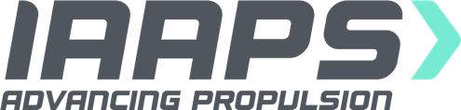
Job Description
Job title: Engineer
Team: Engineering
Reports to: Engineering Manager
Line manages: No line management responsibility
Salary: £36,000
Location: Bristol & Bath Science Park

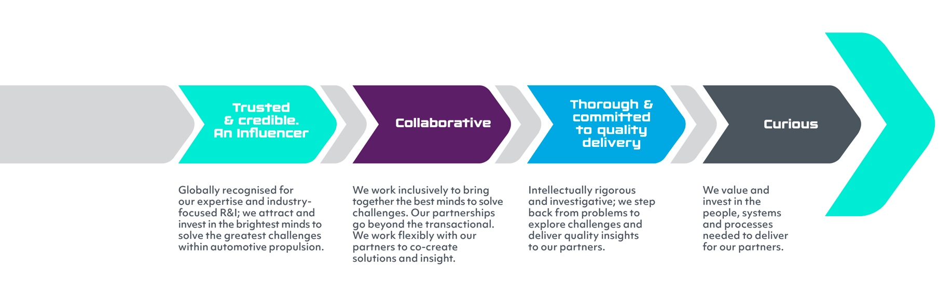
Working at IAAPS
At IAAPS, we strive to attract and select the brightest minds to be part of our team. In this role you will be working within a highly collaborative and cross-disciplinary team, and it is important to us that you can work in a way that reflects the values we believe in. Our values are:

What’s involved?
As a world-leading R&I centre that supports the wider transport and energy sectors in the transition to net zero, we have great ambitions – namely, to solve the industry’s biggest challenges by creating the technologies, tools and systems needed to accelerate the move to clean, affordable and sustainable mobility.

We are a commercial subsidiary of the University of Bath, and our world class facility based at the Bristol & Bath Science Park ranks among the top three independent institutions of its type in the world. With a team in place that brings together specialists from across industry and academia and a range of highly prestigious commercial partners within the automotive, aerospace and marine sectors, IAAPS is now firmly moving into a scale up phase.

The key to our success? Put simply, it’s our people. We are a dynamic SME operating at the forefront of future low carbon mobility, therefore everyone’s contribution matters and makes a real difference to what we achieve together.

As an Engineer, your role will involve:

- Supporting effective cross-functional relationships and collaborations to build and maintain a high-performance team environment
- Playing a role in technical discussions and decisions on project direction. Collaborating with customers, colleagues and liaising with research partners to identify project objectives, and the skills, tools and supporting systems required to meet those objectives
- Executing virtual and physical test and development plans through to technical sign-off
- Defining and configuring instrumentation to ensure accurate operation throughout the research project
- Ensuring accurate, timely, high-quality data from rigs and simulation activity is provided to the project team
- Reviewing data output from work-stream activity, ensuring data accuracy, reliability and quality
- Creation of project and research outputs, including customer project updates, reports, papers, and presentations
- Providing day-to-day support, as part of the team working on projects

What do I need?
- Engineering degree in a relevant subject, typically Mechanical/Electrical/Design
- Technical experience in an engineering research and development environment, ideally electrified powertrain systems, combustion systems and/or system components, using advanced measurement and analysis techniques
- Able to demonstrate a good understanding of one or more of the following areas: Hybrid systems, Electric motors and drives, Internal Combustion Engines, Transmissions and driveline, Turbomachinery, Battery Design and Management, System Simulation, Data Analytics, Artificial Intelligence, Machine Learning
- Working knowledge of software development methodologies and platforms, and collaborative development environments
- Experience of data acquisition systems and knowledge of instrumentation for effective data collection and interpretation
- Advanced data processing and analysis experience using recognised software
- Strong analytical skills; able to demonstrate techniques to understand failure modes and resolve problems.
- Ability to work within a matrix structure, building and maintaining successful working collaborations across IAAPS
- Experience of working effectively on multi-disciplinary projects with a team of engineers and technicians is highly desirable.
- Good communication and relationship-building skills; ability to adapt personal style to different audiences, providing feedback, to project team.
- Ability to work collaboratively to develop solutions to technical challenges; willing to share ideas and engage others in discussions and problem-solving
- A flexible approach to work, with the ability to seek out opportunities to engage in learning, and meaningful development.
- Ability to proactively manage competing demands and deadlines; able to support others to achieve results for the team.

- Understanding and ensuring implementation of appropriate legislative and IAAPS standards, and industry best practice for test facility operation.

Closing date for role -Friday 10th July
Interviews will be held during week commencing 20th July

