

Job Description
Job title: Engineer
Team: Engineering
Reports to: Engineering Manager
Line manages: No line management responsibility
Salary: £36,000 | Location: Bristol & Bath Science Park
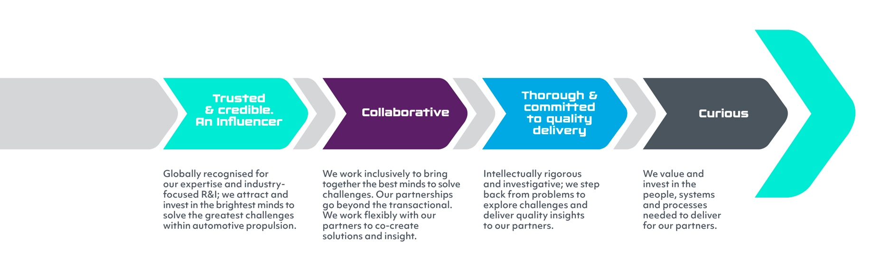
Working at IAAPS
At IAAPS we work inclusively to bring together creative and inventive minds to the greatest challenges. As a team, we believe that diversity of experience, perspectives, and backgrounds leads to a better culture, where our people feel that they belong, contributions are recognised and rewarded, learning is actively encouraged, and difference is celebrated. Our values are:

As a world-leading Research Engineering & Innovation R&I centre that supports the wider transport and energy sectors in the transition to net zero, we have great ambitions – namely, to solve the industry’s biggest challenges by creating the technologies, tools and systems needed to accelerate the move to clean, affordable and sustainable mobility.
We are a commercial subsidiary of the University of Bath, and oOur world class facility based at the Bristol & Bath Science Park ranks among the top three independent institutions of its type in the world. With a team in place that brings together specialists from across industry and academia and a range of highly prestigious commercial partners within the automotive, motorsport, industrial, aerospace, and marine sectors, IAAPS is now firmly moving into a scale up phase.growing in response to the needs of our customers.
The key to our success? Put simply, it’s our people. We are a dynamic SMEteam company operating at the forefront of future low carbon mobilitytechnology, therefore everyone’s contribution matters and makes a real difference to what we achieve together.
What’s involved?
We are looking for a number of Engineers to support our design, digital and physical test teams. As an IAAPS Engineer, your role will involve:
- Executing mechanical and mechatronic design projects, including use of analysis tools, leading to prototype build and validation
- Executing virtual and physical test and development programmes
- Defining and configuring instrumentation to ensure accurate measurements and efficient data acquisition
- Ensuring accurate, timely, high-quality data from test rigs and simulation activities are provided to the project team
- Reviewing and analysing data output, ensuring data accuracy, reliability and quality
- Creation of project outputs, including customer updates, reports, and presentations
- Supporting effective cross-functional relationships and collaborations to build and maintain a high-performance team environment
- Collaborating with customers and colleagues to identify project objectives
- Supporting technical discussions and decisions on project direction, using the skills, tools and supporting systems required to meet those objectives

What do I need?
- An Engineering degree in a relevant subject, typically Mechanical/Electrical/Design
- Technical experience as a design, simulation or test engineer in a research and development environment, including powertrain systems, electrification, combustion systems and/or system components
- Able to demonstrate a good understanding of one or more of the following: Hybrid vehicle systems, Electric motors and drives, Internal Combustion Engines, Transmissions and Driveline, Turbomachinery, Battery Design and Management, System Simulation, Design Processes, Data Analytics, Artificial Intelligence, Machine Learning
- Working knowledge of software development methodologies and platforms, and collaborative development environments
- Experience of data acquisition systems and knowledge of instrumentation for effective data collection and interpretation
- Advanced data processing and analysis experience using recognised software
- Strong analytical skills; able to apply techniques to understand failure modes and resolve problems
General Skills and Competencies
- Ability to work within a matrix structure,working effectively on multi-disciplinary projects with a team of engineers, technicians and support functions
- Good communication and relationship-building skills; ability to adapt personal style to different audiences, providing feedback, to project team
- Ability to work collaboratively to develop solutions to technical challenges; willing to share ideas and engage others in discussions and problem-solving
- A flexible approach to work, with the ability to seek out opportunities to engage in learning, and meaningful development
- Ability to proactively manage competing demands and deadlines; able to support others to achieve results for the team
- Understanding and ensuring implementation of appropriate legislative and IAAPS standards, and industry best practice for test facility operation

Our staff benefit from:
- Flexible working
- Free on-site parking
- Regular IAAPS social events
- Holiday purchase scheme for up to 5 extra days of holiday per year
- Private medical insurance
- Cycle to work scheme
- Up to £8,000 towards relocation expenses (subject to eligibility)

Location and Flexibility:
This role is based at the Bristol & Bath Science Park. We operate a hybrid working model, expecting a minimum of 60% on-site presence. This on-site focus is crucial for developing internal communications, building customer relationships, and delivering project activities.
It is expected that this is a full-time position. However, we would consider flexible working options to cover this.

An IAAPS Open-Evening event will be held prior to the closing date, details will be posted on our website and on social media channels
Closing date – Monday 9th November, 2026
Interviews will be held during week commencing 23rd November

www.iaaps.co.uk | Instagram | LinkedIn

